Name: Phat Gia Tran

Monash ID: 32933983

Lab: Wednesday 6 PM

Tutor name: Ashwini

<https://ptra0022.github.io/Homework-Week-9/>

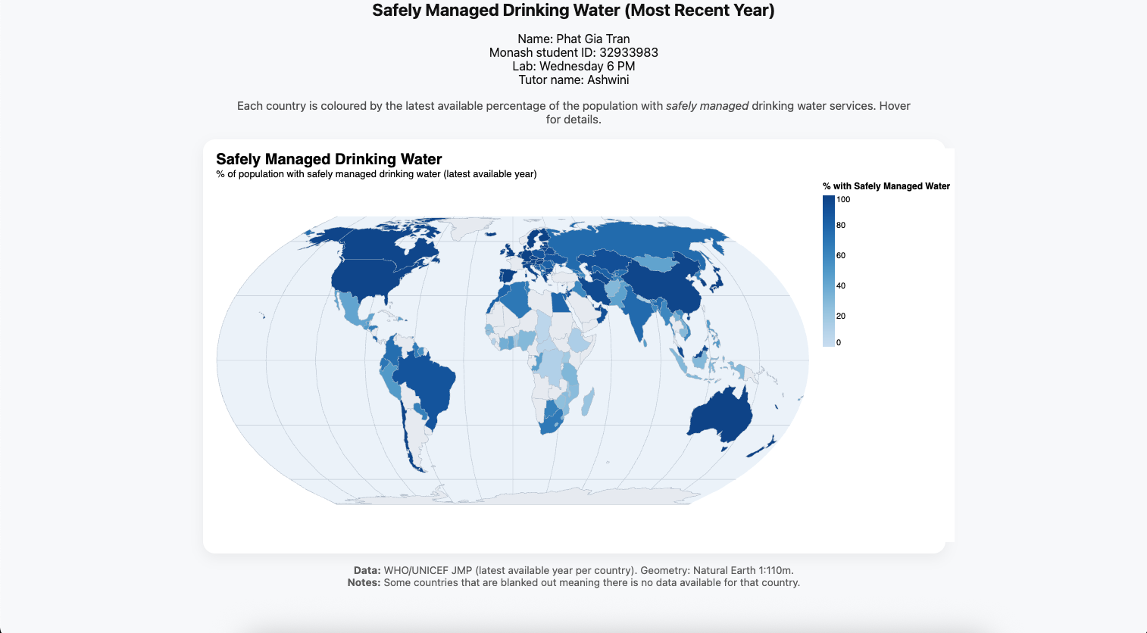

Domain of visualisation:

Global public health and sustainable development—specifically access to safely managed drinking-water services.

Visualised dataset (attributes, source, author):

WHO/UNICEF Joint Monitoring Programme (JMP) for Water Supply, Sanitation and Hygiene.

Attributes used:

* iso3 (country code, nominal)
* country (country/territory name, nominal)
* latest_year (most recent reporting year – in this case 2024, since 2025 data has not been finalized, quantitative)
* access_percentage (percentage of population with safely managed drinking water, quantitative).

Data transformation applied:

Filtered to the most recent available year (2024) for each country and normalised the measure to percentage of total population to allow comparison across countries of different sizes.

Justification of map idiom:

A choropleth map was chosen because the variable of interest, percentage of population with safely managed drinking water, is a rate/density measure tied to geographic areas. Colour shading effectively communicates variations in access across countries, whereas proportional symbol or dot maps are more appropriate for absolute counts or point locations.